# Installing GeoEvent with BDS on AWS Servers/Local VM’s

The full installation took a couple of hours on AWS; a little longer on local VM’s.

## AWS Servers Hardware

OS: Windows 2012 R2

RAM: 15GB

HD: 100GB

## Configuring Server Names

For installation the servers will need to have valid DNS entries. AWS Servers have valid names; however, they are often very long (e.g. c2-54-215-244-88.us-west-1.compute.amazonaws.com). To simplify using the servers I renamed them and gave them short names (e.g. gis.gee.tst). This also works if you have created a local VM using VirtualBox,VMWare,or KVM (Included with CentOS/Red Hat). For AWS you could just use the DNS names if you don’t mind entering long names in URL’s.

In Server Manager -> Local Server click on Computer Name. Click on Change Name set the Computer name (e.g. gis); then click on “More” and set Primary DNS suffix on this computer (e.g. gee.tst). For local VirtualBox VM’s I used two Network cards one “NAT” and one “Host-only”. Then set Host-only for fixed IP address. For AWS I used the internal IP address (172.x.x.x); fixed IP’s should be used.

You’ll need to do this for each server. For example I named my Data servers (d1.gee.tst, d2.gee.tst, etc.)

On each server I then edited the “hosts” file. In Windows this file is located in C:\Windows\System32\drivers\etc.

NOTE: You will like need to open the text editor (e.g. Notepad) as Administrator.

Add entries for each of your servers. For example:

172.3.12.100 gis.gee.tst  
172.3.12.101 d1.gee.tst  
172.3.12.102 d2.gee.tst  
173.3.12.103 d3.gee.tst

You’ll need to restart the server for the name change to take effect.

## Security Adjustments

If you want to access management from other servers you’ll need to open Firewall to allow access to 6143 (geoevent) and 6443 (ArcGIS Server).

Additional ports need to be open between GIS server and Data Servers for BDS: 9220, 9320, and 2181

To support testing you will also need to open ports for TCP in and TCP out: 5565 and 5575 by default.

Create a Rule to allow inbound connections to ports required.

You could disable the Firewall for testing; however, do not do this on operational servers.

Disable IE Enhanced Security Configuration. Server Manager -> Local Server. By default this is on and can making managing services via IE very painful.

## Install ArcGIS Server

Defaults for installation.

Create a local system user “arcgis” for the service account. You’ll need to create a password with sufficient complexity for system security policies. Write it down.

After install Web Page will open to allow you to create a site. Create a new site and set the AGS admin username and password. Write them down.

You’ll need to authorize the software. (e.g. Server_Ent_Adv.ecp works)

## Install Web Adaptor (arcgis)

Installer will ask to install necessary IIS components if they are not installed. Let it install these components. Use the default “arcgis” for WA for ArcGIS Server.

After install Web Page will open to allow you to configure web adaptor for ArcGIS Server or Portal. Select ArcGIS Server and configure. You can allow manager access (especially for a test environment); for operational environments I wouldn’t allow manager access via Web Adaptor.

## Configure IIS for https / 443

In IIS Manager select “Server Certificate” and create a new self-signed certificate. Certificate Store for Web Hosting worked.

From Default Web Site modify bindings and enable https/443 and configure it to use the new self-signed certificate you just created.

## Install Data Store

Defaults for installation.

After installation a web page will open. Connect Data Store to ArcGIS Server. After it connects you’ll get a message that ArcGIS Server needs to be federated with Portal.

## Install Portal for ArcGIS

Defaults for installation.

After installation completes a web page will open. Create a new portal user. You can use your email address. Set an admin username and password. Write them down.

Export the certificate used by portal on port 7443. In IE you’ll see a “Certificate error” in the browser URL. Click on the error and view the certificate. In the details panel “Copy to File”. Put the file someplace where you’ll remember where it is.

Log into ArcGIS Server admin (e.g. <https://gis.gee.tst:6443/arcgis/admin>). Navigate to machines -> GIS.GEE.TST -> sslcertificates. Click on importRootOrIntermediate certificate. Browse to the portal port 7443 certificate you exported and click import. This is required for GeoEvent to authenticate to portal.

You’ll need to authorize the software. (e.g. Portal_100.ecp works)

## Install Web Adaptor (portal)

Use “portal” for WA for Portal. Select port 443.

After install Web Page will open to allow you to configure web adaptor for ArcGIS Server or Portal. Select Portal and configure. Several times I got an error on my first couple of attempts. I believe portal takes a few minutes to get started.

## Register ArcGIS Server as Federated

Log into Portal (e.g. <https://gis.gee.tst/portal/home>). Under My Organization click Edit Settings then select Server. Click Add Server and add your ArcGIS Server. Then under “Hosting Server” set it to the newly registered Server. Click Save.

## Install GeoEvent

Installer will ask to install necessary IIS components if they are not installed. Let it install these components. Use the default “arcgis” for WA for ArcGIS Server.

After install Web Page will open to allow you to configure web adaptor for ArcGIS Server or Portal. Select ArcGIS Server and configure. You can allow manager access (especially for a test environment); for operational environments I wouldn’t allow manager access via Web Adaptor.

Update Default Data Store Connection. Log into GeoEvent Manager (e.g. <https://gis.gee.tst:6143/geoevent/manager>). Note you’ll be redirected to authenticate using your Portal username/password. Click on Site and Data Stores. The Default will have an error. Edit and change to “Use Web Tier Authentication”. Specify the portal admin username and password and click Register. You should now see a green check.

## Data Servers Installation

Install Data Store with default; however, do not complete the web form after installation.

After install open a Command Prompt as Administrator.

Change to the tools directory. C:\Program Files\ArcGIS\DataStore\tools

Run command to configure the BDS.

>configuredatastore.bat <https://gis.gee.tst:6443/arcgis/admin> siteadmin **PASSWORD** c:\arcgisdatastore --stores spatiotemporal

After a few minutes you should see confirmation (Operation completed successfully) that the data store was configured.

Login to ArcGIS Server Admin (e.g. <https://gis.gee.tst:6443/arcgis/admin>) and navigate to data -> items.

You should see a /nosqlDatabases link; click on that and then click on Child Item. Then click on REST.

Write down the username and password for the admin. This is used in the Performance Test Harness when testing Elasticsearch output.

### Optional Exploration of ElasticSearch

If you want to explore ElasticSearch directly you’ll need to decrypt the password. The password can be decrypted using decryptBDSPassword.

>java -jar decryptBDSPassword {crypt}VovBzQGONbtJnPw02rmmag==

tocur94vfo

Using this password and the username (e.g. els_ro5fnhw) you can access.

<http://d1.gee.tst:9220>

If you do this you should see the status page for Elasticsearch.

{

"status" : 200,

"name" : "D1.GEE.TST",

"cluster_name" : "bds_tocur94v",

"version" : {

"number" : "1.6.2",

"build_hash" : "622039121e53e5f520b5ff8720fdbd3d0cb5326b",

"build_timestamp" : "2015-07-29T09:24:47Z",

"build_snapshot" : false,

"lucene_version" : "4.10.4"

},

"tagline" : "You Know, for Search"

}

All of the standard Elasticsearch Queries can be used on this now. <https://www.elastic.co/guide/en/elasticsearch/guide/current/index.html>

## Create GeoEvent Test Service

Import the GeoEventConfig-BDS.xml into GeoEvent. This will create the FAA-Stream GeoDefinition.

### Input

Create new Input “Receive Text from a TCP Socket”. Use the default port 5565.

Name: tcp-text-in

Create new Output “Add a Feature to an ArcGIS Spatiotemporal Big Data Store”

### Output

Name: bds-out  
GeoEvent Definition: FAA-Stream  
ArcGIS Server Connection: Default

Click on Create Data Source

Name: FAA-Stream (This will be the IndexName and IndexType)  
Create: Uncheck Feature Service   
Display Field Name: Change to “Name”

Click Publish

Click Save to create the Output.

### Create a GeoEvent Service

Name can be whatever you want. Tcp-text-in connected to bds-out

Click Publish.

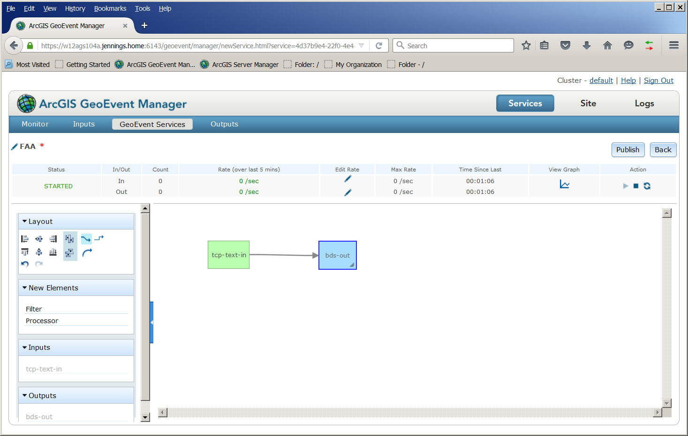

From Monitor Tab

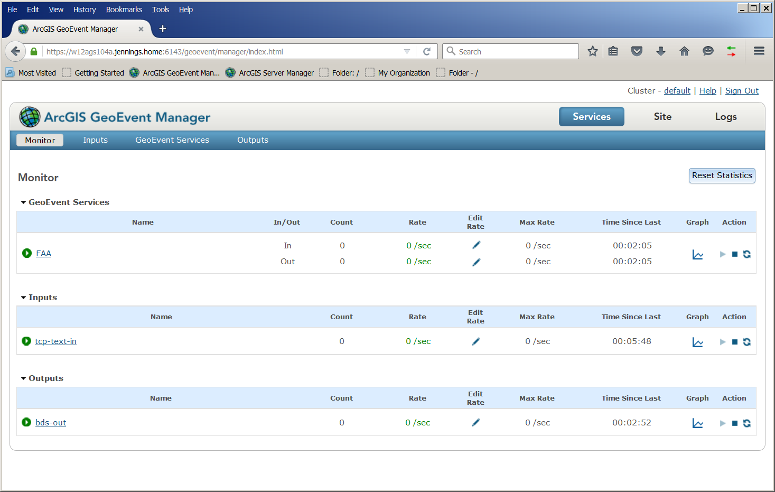

You should be able to run PTH without compiling. The executables are all in “app” folder in the download. A sample fixture for Elasticsearch (BDS) test is in app/fixtures folder. Named fixture_es.xml.

The test is for tcp in and ElasticSearch (es) out. Use the faa-stream.csv file for input.

For TCP configuration use the GIS server as the hosts. Port 5565 must be accessible from the test server.

For ES configuration use one of the data server. The username and encrypted password as found on the ArcGIS Server Admin page. (e.g. https://w12ags104a.jennings.home:6443/arcgis/admin/data/items/nosqlDatabases/AGSDataStore_bigdata_bds_tocur94v)

Three command windows

1. java –jar Producer.jar –p 5010
2. java –jar Consumer.jar –p 5020 –t es
3. java –jar Orchestrator.jar –f fixtures\fixture_es.xml

The test results will be written (as specified in the config) to reports\es.csv.

For my Local VM’s I see a max BDS write speed of around 1,700 e/s for AWS Server the max BDS write speed is around 4,000 e/s. These results were for buildnum’s 5493 (Portal,AGS,WA,DS) and 5498 (GeoEvent).

This is pretty close to max throughput for tcp-in -> NoOp -> tcp-out.